Project Report
India's Agricultural Crop Production Analysis

TEAM MEMBERS

- D. Sindhu
- Shaik Mohammed Amaan

1. INTRODUCTION

1.1 Project Overview
Agriculture is one of the most important sectors of the Indian economy, contributing significantly to employment, food security, and national development. India has diverse climatic conditions and agricultural practices that support the cultivation of a wide range of crops across different states and seasons. As agricultural data continues to grow over the years, it becomes increasingly important to analyze this information effectively to identify production trends, regional variations, and seasonal patterns that can support informed decision-making.
The India's Agricultural Crop Production Analysis project is designed to provide a comprehensive visual analysis of India's agricultural production using historical crop production data from 1997 to 2021. The project leverages Tableau, a powerful Business Intelligence and Data Visualization tool, to transform raw agricultural data into interactive dashboards and stories. These visualizations enable users to explore crop production across different states, seasons, and years in an intuitive and meaningful way.
The project focuses on analyzing crop-wise, state-wise, and season-wise agricultural production to identify high-performing crops, regional productivity differences, and long-term production trends. Interactive dashboards, filters, maps, charts, and visual stories allow users to uncover valuable insights that are difficult to identify from raw datasets alone.
This analysis is intended to support multiple stakeholders with different objectives. Farmers can use historical production trends to make better crop selection decisions and reduce farming risks. Government policymakers can identify low-performing regions, evaluate seasonal variations, and formulate effective agricultural policies. Agribusiness investors can analyze production patterns and identify high-growth crops and regions to make informed investment decisions.
The project demonstrates how data preprocessing, data analysis, and business intelligence techniques can convert complex agricultural datasets into meaningful insights. By presenting the information through interactive Tableau dashboards and stories, the project enhances understanding of India's agricultural landscape and promotes data-driven decision-making for sustainable agricultural development.

1.2 Purpose
The purpose of the India's Agricultural Crop Production Analysis project is to analyze historical agricultural production data from 1997 to 2021 and present meaningful insights through interactive data visualizations using Tableau. The project aims to transform complex agricultural datasets into easy-to-understand dashboards and stories that help users explore crop production trends, seasonal variations, regional distribution, and year-over-year performance.
This project is designed to support data-driven decision-making for various stakeholders, including farmers, government policymakers, researchers, and agribusiness investors. Farmers can identify suitable crops and seasons based on historical production patterns, policymakers can evaluate regional agricultural performance and formulate effective policies, and investors can recognize highgrowth crops and regions for investment opportunities.
The project also demonstrates the practical application of data preprocessing, data analysis, and business intelligence techniques in solving real-world agricultural challenges. By providing interactive dashboards and visual storytelling, the project makes agricultural data more accessible, understandable, and useful for improving productivity, planning, and sustainable agricultural development

2. IDEATION PHASE

2.1 Problem Statement
Agriculture is a vital sector of India's economy, generating vast amounts of crop production data every year. However, this data is often stored in large datasets that are difficult to analyze and interpret. Farmers, government agencies, researchers, and agribusiness investors face challenges in identifying production trends, seasonal variations, and regional performance due to the lack of interactive analytical tools.
Traditional methods of data analysis provide limited insights and make it difficult to compare crop production across different states, seasons, and years. As a result, stakeholders may struggle to make informed decisions regarding crop selection, policy formulation, resource allocation, and investment planning.
This project addresses these challenges by developing an interactive Tableau-based analytics solution that transforms historical agricultural data (1997–2021) into meaningful dashboards and stories. The visualizations enable users to explore production trends, compare regional performance, analyze seasonal variations, and support data-driven decision-making in the agricultural sector.

2.2 Empathy Map Canvas
User: Farmer / Government Policy Analyst / Agribusiness Investor

Says Thinks
"Which crop should I cultivate?" Which crop has the highest production?
"Which state performs best?" How has production changed over the years?
"I need reliable agricultural insights." Which season gives better crop yields?
Does Feels

Does Feels

Analyzes production reports Concerned about unpredictable production trends
Compares states and crops Wants accurate information for better decisions
Uses dashboards to explore data Needs confidence before making investments or policies

2.3 Brainstorming
During the brainstorming phase, several ideas were discussed to determine the most effective way to analyze and visualize India's agricultural data. The focus was on developing an interactive solution that would simplify complex datasets and provide meaningful insights for different stakeholders.
The following ideas were considered:
- Analyze crop production trends from 1997–2021.
- Compare agricultural production across different states and union territories.
- Study production patterns for Kharif, Rabi, and Zaid seasons.
- Identify the highest and lowest producing crops and regions.
- Create KPI cards to display key agricultural statistics.
- Develop interactive dashboards with filters for crop, state, season, and year.
- Build a Tableau Story to present insights in a logical sequence.
- Deploy the project as a web application for easy accessibility.
- Maintain the project source code and documentation using GitHub.
After evaluating these ideas, an interactive Tableau dashboard and storytelling solution was selected as the most effective approach for presenting agricultural insights and supporting data-driven decision-making.

3. REQUIREMENT ANALYSIS

3.1 Customer Journey Map
The customer journey map illustrates how different stakeholders interact with the agricultural analytics system to achieve their objectives.
Stage Farmer Government Policy Analyst Agribusiness Investor

^{Need} Select suitable crops and Analyze agricultural Identify profitable crops and

Stage Farmer Government Policy Analyst Agribusiness Investor
improve yield performance and plan policies investment opportunities

Access agricultural Review state-wise and seasonal Explore production trends and
Search reports regional growth
dashboard

Compare crop production Evaluate production patterns Compare crop performance
Analysis and low-performing areas and historical trends
by season and region

Choose appropriate crops Develop policies and allocate Invest in high-growth crops
Decision resources and regions
and planting season

Increased productivity and Better policy planning and Reduced investment risk and
Outcome improved returns
income agricultural development

3.2 Solution Requirement

Functional Requirements
- Import and process agricultural production data.
- Display crop-wise, state-wise, and season-wise analysis.
- Provide interactive filters for year, crop, state, and season.
- Display Key Performance Indicators (KPIs) such as total production, number of crops, states, and years.
- Generate interactive dashboards and visual stories.
- Allow users to explore trends and compare agricultural performance.

Non-Functional Requirements
- User-friendly interface.
- Fast dashboard loading and response time.
- Accurate and reliable data visualization.
- Interactive and responsive design.
- Easy maintenance and scalability.
- Secure deployment through GitHub and Vercel.

Software Requirements
- Tableau Public
- Microsoft Excel
- Visual Studio Code
- GitHub
- Vercel
- Web Browser (Google Chrome/Microsoft Edge)

Hardware Requirements
- Processor: Intel Core i3 or above
- RAM: Minimum 4 GB (8 GB recommended)
- Storage: Minimum 10 GB free space
- Internet connection
- Windows 10/11 or equivalent operating system

3.3 Data Flow Diagram

Level-0 Data Flow Diagram
+ +
| Agricultural Dataset |
| (1997–2021) |
+ + +
| v
+ +
| Data Preprocessing |
| (Cleaning & Filtering)|
+ + +
| v
+ +
| Tableau Processing |
| Dashboard & Story |
+ + +
| v
+ +
| Interactive Website |
| (Vercel Deployment) |
+ + +
| v
+ +
| End Users |
| Farmers, Policymakers|
| Investors |
+

+

3.4 Technology Stack

Technology Purpose
Tableau Public Creating interactive dashboards and stories

Microsoft Excel Data cleaning and preprocessing
CSV Dataset | Agricultural crop production data
HTML5 | Web page structure
CSS3 | Styling and layout
Bootstrap 5 | Responsive user interface
JavaScript | Interactive website functionality
Technology | Purpose
GitHub | Source code management and version control
Vercel | Deployment and hosting of the project website
Web Browser | Viewing dashboards and website

4. PROJECT DESIGN

4.1 Problem Solution Fit
The agricultural sector generates a large volume of crop production data every year, making it difficult for stakeholders to analyze and extract meaningful insights using traditional methods.
Farmers often struggle to identify suitable crops and seasons, policymakers require reliable data for planning and resource allocation, and investors need historical trends to make informed investment decisions.
The proposed solution addresses these challenges by developing an interactive data visualization platform using Tableau. Historical agricultural data from 1997–2021 is cleaned, processed, and transformed into interactive dashboards and stories. Users can analyze crop production based on state, season, crop type, and year, enabling better understanding of agricultural trends and supporting data-driven decision-making.
This solution simplifies complex datasets through visual analytics, making agricultural information more accessible, interactive, and actionable for different stakeholders.

4.2 Proposed Solution
The proposed solution is a Tableau-based Business Intelligence system that analyzes India's agricultural crop production data from 1997 to 2021. The system converts raw agricultural data into interactive dashboards and visual stories, allowing users to explore production trends, seasonal variations, regional performance, and crop-wise analysis.
The solution includes the following features:
- Interactive dashboards with filters for crop, state, season, and year.
- KPI cards displaying important agricultural statistics.
- State-wise and crop-wise production analysis.
- Seasonal production comparison (Kharif, Rabi, and Zaid).
- Year-over-year production trend analysis.
- Tableau Story for guided visualization of insights. • Responsive web interface deployed using
Vercel.
- GitHub repository for source code and project documentation.
This solution enables farmers, policymakers, researchers, and investors to gain meaningful insights and make informed decisions based on historical agricultural data.

4.3 Solution Architecture
The overall architecture of the system consists of multiple stages, beginning with data collection and ending with interactive visualization for end users.
Agricultural Dataset
(1997–2021)
│
▼
Data Cleaning & Preprocessing
(Microsoft Excel)
│
▼
Data Visualization (Tableau)
Dashboards • Stories • KPI Cards
│
▼
Website Integration (HTML,
CSS, Bootstrap & JavaScript)
│
▼
Deployment (GitHub + Vercel)
│
▼
End Users
┌──────────┬──────────────┬───────────────┐
│ Farmers │ Policymakers │ Investors │
└──────────┴──────────────┴───────────────┘

Architecture Description
- Data Collection: Agricultural crop production data (1997–2021) is collected from the dataset.
- Data Preprocessing: The dataset is cleaned, organized, and prepared using Microsoft Excel.
- Data Visualization: Tableau is used to create interactive dashboards, charts, maps, KPI cards, and stories.
- Website Integration: The Tableau dashboards are embedded into a responsive website developed using HTML, CSS, Bootstrap, and JavaScript.
- Deployment: The website and project source code are deployed using Vercel and GitHub for public access.
- End Users: Farmers, government policymakers, researchers, and agribusiness investors use the platform to explore insights and support data-driven decision-making.

5. PROJECT PLANNING & SCHEDULING

5.1 Project Planning
Day | Activity
Day 1 | Requirement analysis, problem understanding, and dataset collection
Day 2 | Data cleaning and preprocessing using Microsoft Excel
Day 3 | Dashboard design and visualization development in Tableau
Day 4 | Tableau Story creation and dashboard refinement
Day 5 | Website development and Tableau dashboard integration
Day 6 | Testing, debugging, and deployment using GitHub and Vercel
Day 7 | Documentation, project report preparation, and final submission

Project Workflow
Requirement Analysis
↓
Dataset Collection
↓
Data Cleaning & Preprocessing
↓
Dashboard Development (Tableau)
↓
Story Creation
↓
Website Development
↓
Testing & Deployment
↓
Documentation & Final Submission

Milestones Achieved
- ✔ Requirement analysis completed.
- ✔ Agricultural dataset collected and preprocessed.
- ✔ Interactive Tableau dashboards developed.
- ✔ Tableau Story created successfully.
- ✔ Responsive website integrated with Tableau.
- ✔ Project deployed using GitHub and Vercel.
- ✔ Documentation and final report completed.

6. FUNCTIONAL AND PERFORMANCE TESTING
Testing was conducted to ensure that the agricultural analytics system functions correctly, provides accurate visualizations, and delivers a smooth user experience. Both functional and performance testing were performed to verify the reliability and efficiency of the Tableau dashboards and the deployed web application.

6.1 Performance Testing
Performance testing was carried out to evaluate the responsiveness, stability, and usability of the application under normal operating conditions. The results indicate that the system performs efficiently and provides quick access to interactive dashboards and visualizations.

Performance Test Cases

Test Case Expected Result | Actual Result | Status
Home page opens correctly Website loads successfully | Website loaded successfully | Pass
Tableau dashboard loading Dashboard loads without errors | Dashboard loaded correctly | Pass
Story pages navigate smoothly Tableau Story navigation | Navigation successful | Pass
Filters update visualizations correctly Dashboard filters | Filters functioned properly | Pass

Interactive charts | Charts respond to user interaction | Interactive response verified | Pass
State, Crop, and Season selection | Displays accurate filtered results | Accurate results displayed | Pass
Cross-device compatibility | Website works on desktop and mobile browsers | Responsive layout verified | Pass
GitHub repository accessibility | Repository opens successfully | Repository accessible | Pass
Website response time | Pages load within acceptable time | Response time satisfactory | Pass
Data accuracy | Visualizations match the dataset | Data verified successfully | Pass

Performance Summary
- The website loads efficiently on modern web browsers.
- Tableau dashboards and stories are displayed correctly without rendering issues.
- Interactive filters provide quick and accurate updates to the visualizations.
- The application maintains consistent performance during navigation between dashboards and stories.
- The responsive web design ensures accessibility across different screen sizes and devices.
- The deployed application and GitHub repository are publicly accessible for project demonstration and evaluation.
Overall, the testing results confirm that the system meets the required functional and performance standards, providing users with a reliable, interactive, and efficient platform for analyzing India's agricultural crop production data.

7. RESULTS
The India's Agricultural Crop Production Analysis project was successfully developed and implemented using Tableau for data visualization and a responsive web interface for project presentation. Historical agricultural production data from 1997–2021 was analyzed to generate meaningful insights through interactive dashboards and visual stories.
The developed system enables users to explore crop production based on state, crop type, season, and year. Interactive filters, KPI cards, charts, and maps help users understand agricultural trends, identify high-performing regions, and compare production across different categories.
The Tableau dashboards provide a comprehensive overview of India's agricultural production, while the Story feature presents important findings in a structured and easy-to-understand manner. The project successfully meets its objectives by transforming raw agricultural data into visually appealing and actionable insights that support farmers, policymakers, researchers, and agribusiness investors in making informed decisions.
The project was deployed successfully, allowing users to access the dashboards and stories through a web application. Overall, the system demonstrates the effective use of Business Intelligence and data visualization techniques for agricultural data analysis.

7.1 Output Screenshots
The following screenshots demonstrate the successful implementation of the project:

Figure 7.1: Home Page

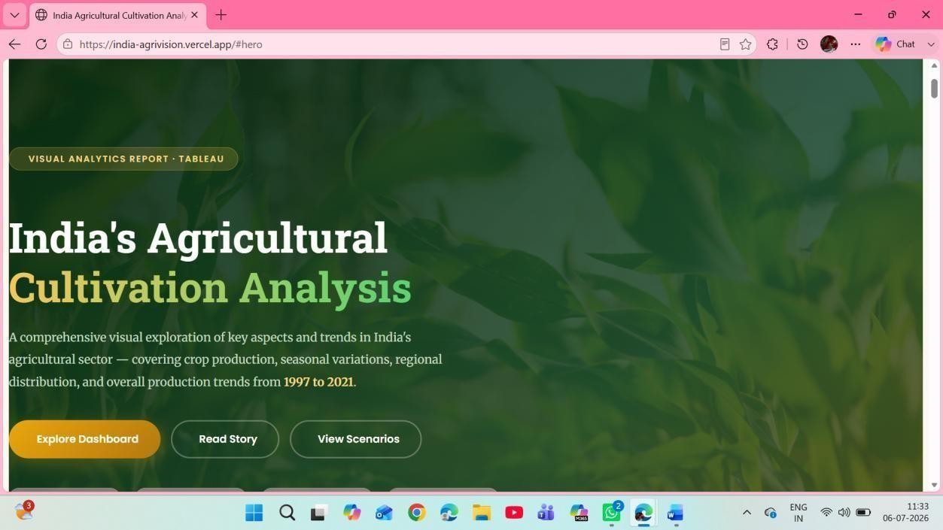

Figure 7.2: Dashboard Overview

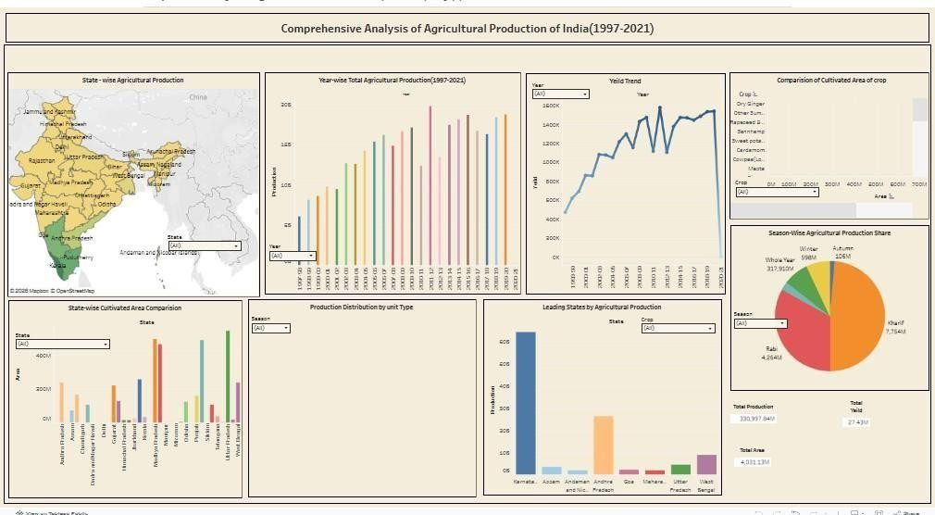

Figure 7.3: State-wise Agricultural Production Analysis
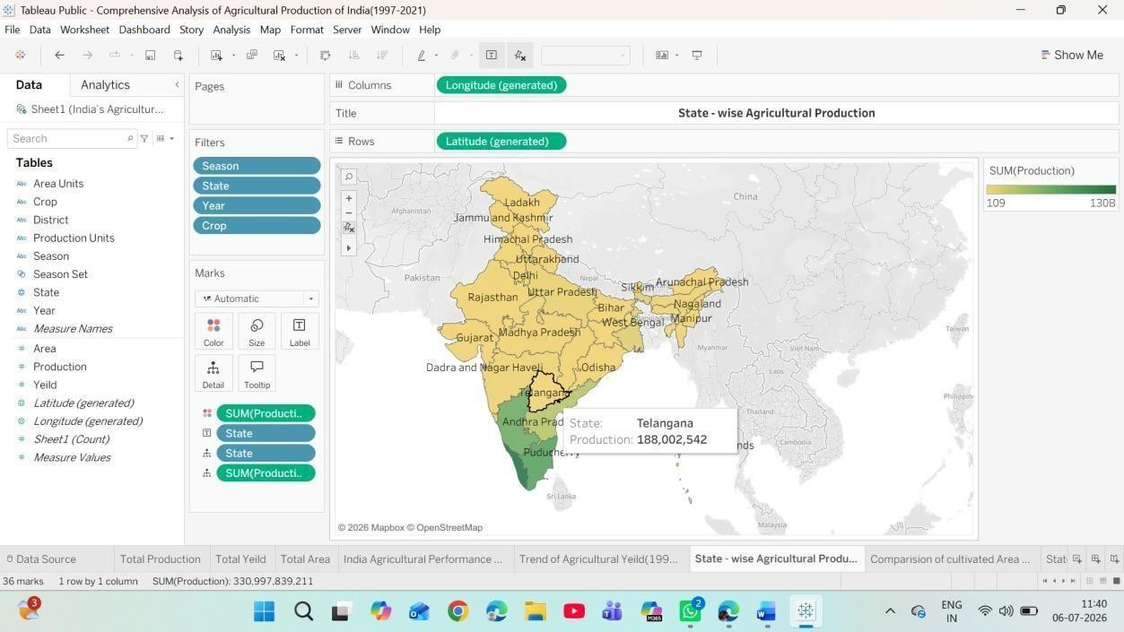

Figure 7.4: Crop-wise Production Analysis

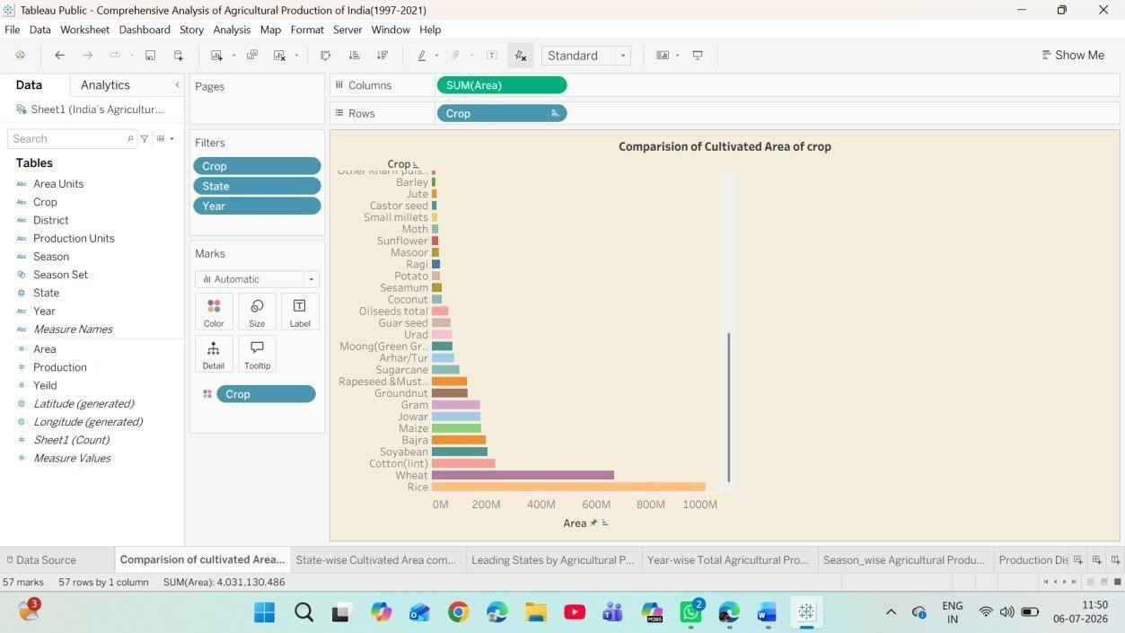

7.5: Season-wise Production Analysis

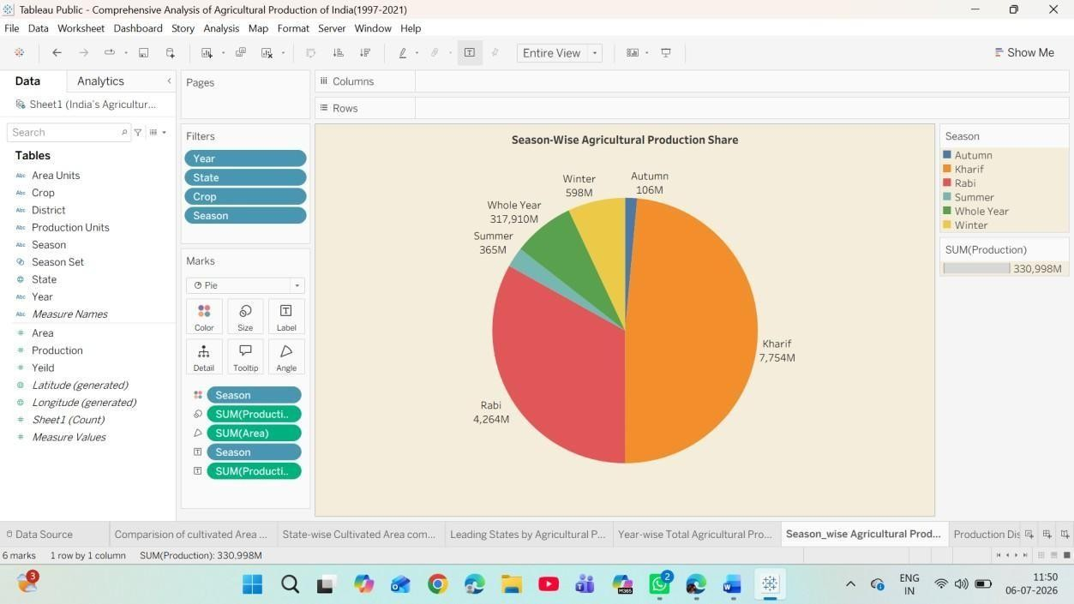

Figure 7.6: Year-wise Production Trend
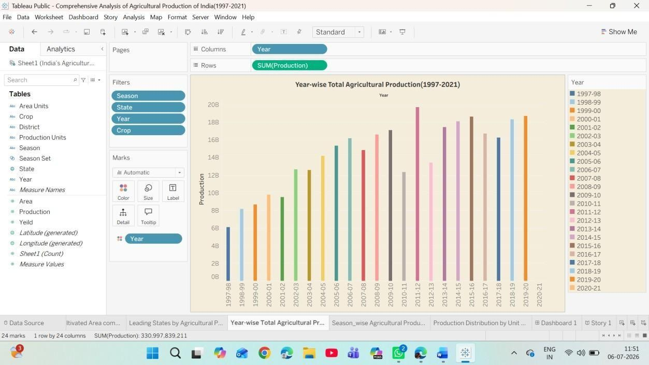

7.7: Interactive Tableau Story

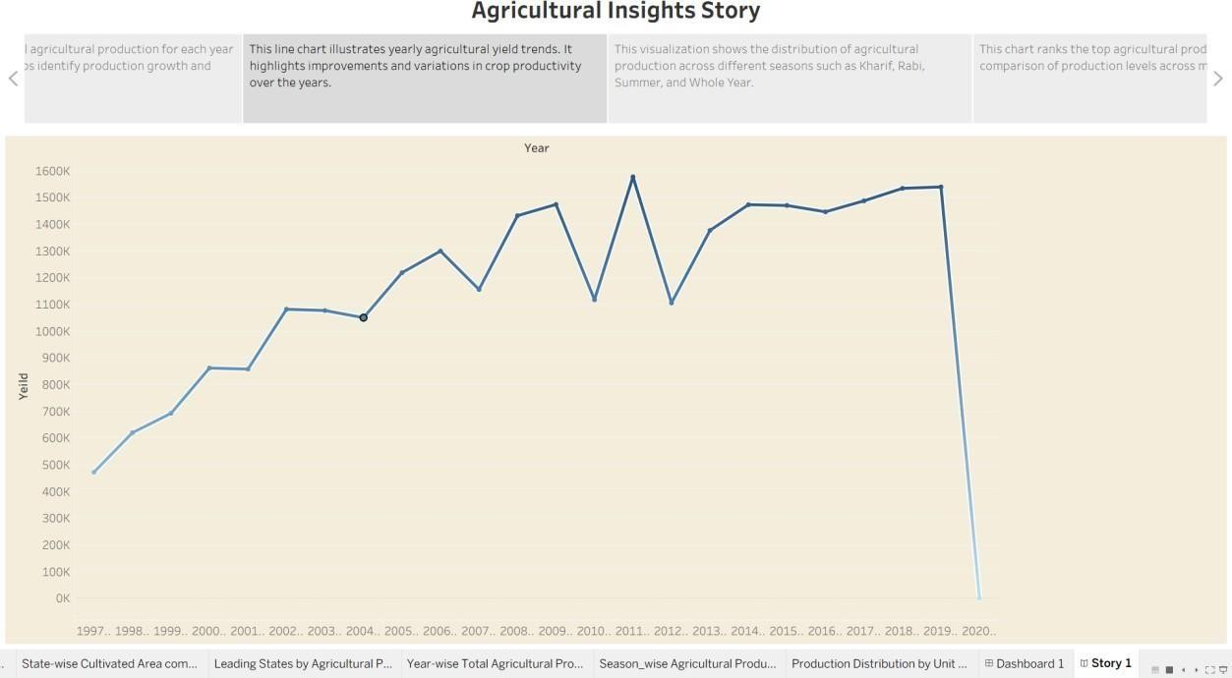

Figure 7.8: Project Website

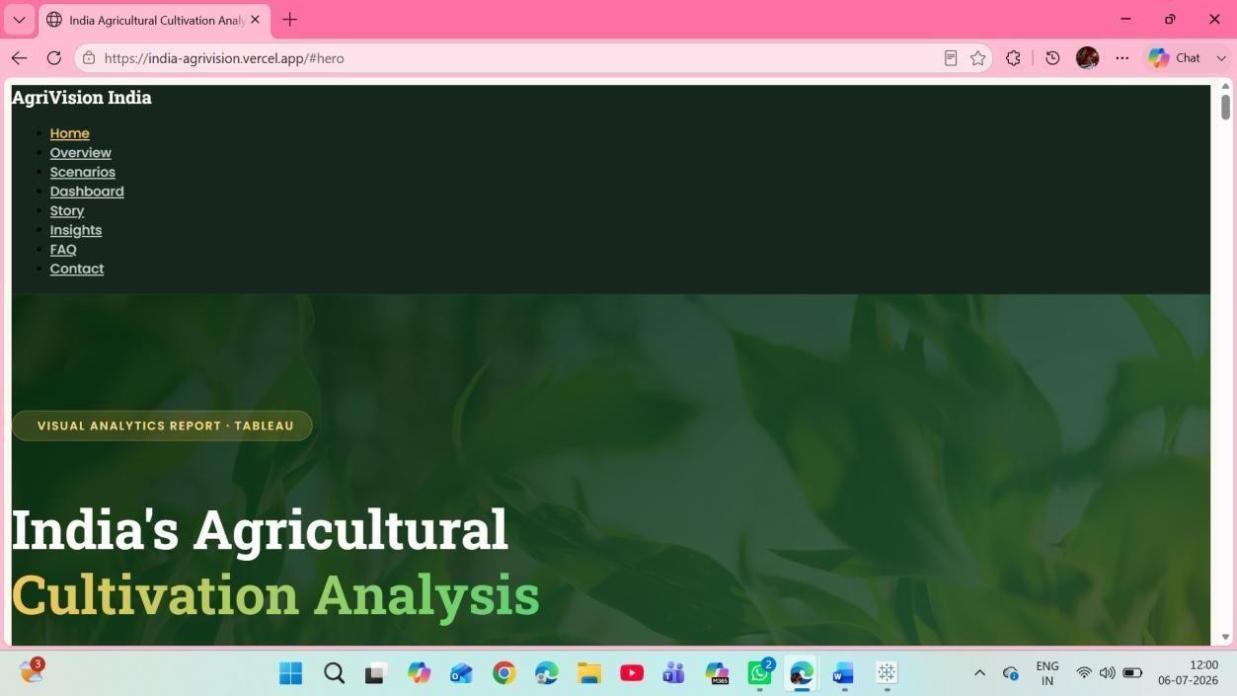

7.9: GitHub Repository

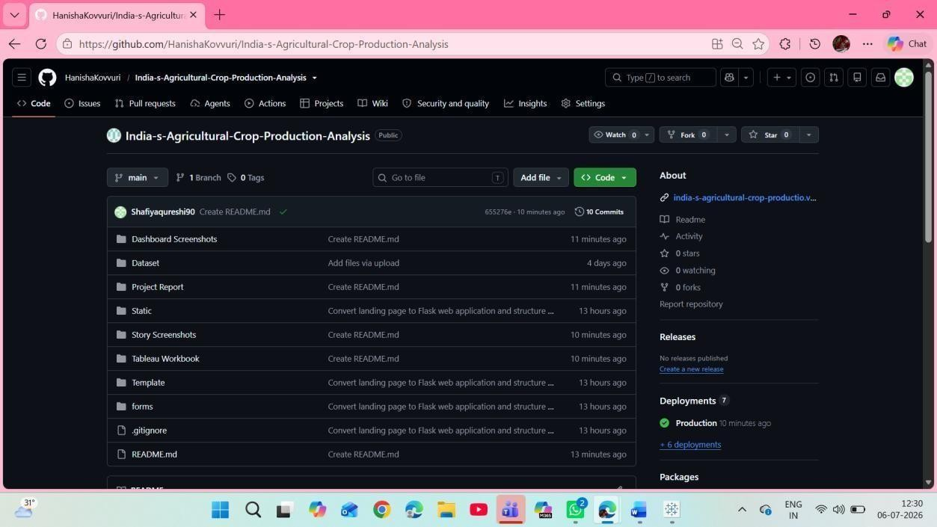

Figure 7.10: Tableau Public Dashboard

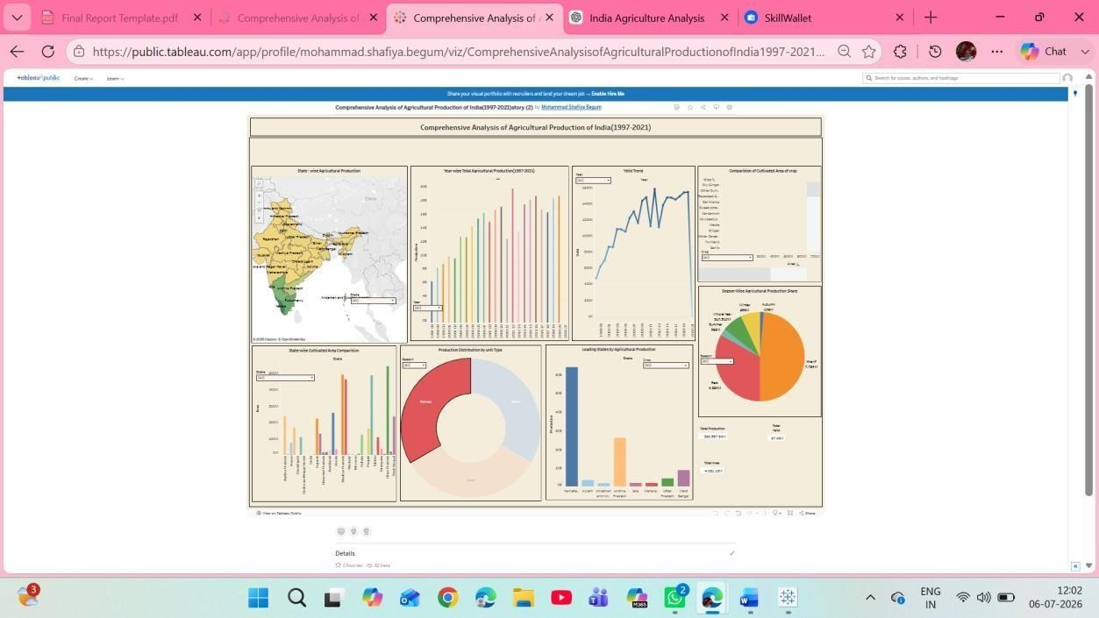

Result Summary
- Successfully analyzed agricultural crop production data from 1997–2021.
- Developed interactive Tableau dashboards and stories.
- Visualized crop-wise, state-wise, season-wise, and year-wise production trends.

Figure
- Implemented interactive filters for easy data exploration.
- Created a responsive web application for project presentation.
- Successfully deployed the project using Vercel and maintained the source code on GitHub.
- Generated meaningful insights to support data-driven decision-making in the agricultural sector.
8. ADVANTAGES & DISADVANTAGES

Advantages
- Provides interactive and easy-to-understand visualizations of agricultural data.
- Enables analysis of crop production by state, crop type, season, and year.
- Supports data-driven decision-making for farmers, policymakers, and investors.
- Helps identify production trends and regional performance over time.
- Interactive filters allow users to customize their analysis.
- Tableau dashboards and stories improve data interpretation through visual storytelling.
- The responsive web application allows users to access the project from different devices.
- The project integrates data analysis, visualization, and web deployment into a single platform.

Disadvantages
- The analysis is based only on historical data (1997–2021) and does not include real-time updates.
- Weather conditions and climate data are not incorporated into the analysis.
- Market price information and demand forecasting are not included.
- The project depends on the quality and completeness of the available dataset.
- Tableau Public requires an internet connection to access the published dashboards.

9. CONCLUSION
The India's Agricultural Crop Production Analysis project successfully demonstrates the application of Business Intelligence and data visualization techniques in the agricultural sector. By analyzing historical crop production data from 1997 to 2021, the project provides valuable insights into crop production trends, seasonal variations, regional distribution, and year-wise performance.
Interactive Tableau dashboards and stories enable users to explore agricultural data efficiently and make informed decisions based on visual insights. The project supports the needs of farmers, government policymakers, researchers, and agribusiness investors by presenting complex datasets in a simple and meaningful format.
Overall, the project highlights the importance of data-driven decision-making in agriculture and showcases how modern visualization tools like Tableau can transform raw data into actionable information that contributes to improved agricultural planning and sustainable development.

10. FUTURE SCOPE
The project can be further enhanced by incorporating additional features and advanced analytical techniques. Some possible future improvements include:
- Integrate real-time agricultural production data.
- Include weather and climate data for more comprehensive analysis.
- Develop machine learning models for crop yield prediction.
- Add market price and demand forecasting for better investment decisions.
- Build a mobile application for easier access by farmers.
- Implement AI-based crop recommendation systems.
- Incorporate satellite imagery and GIS-based agricultural analysis.
- Provide multilingual support to improve accessibility for users across India.
- Develop predictive dashboards for future agricultural planning.

11. APPENDIX

Source Code
The complete project source code, including the website files, Tableau integration, and project documentation, is maintained in a GitHub repository for version control and collaboration.

Dataset Link:
The dataset used for this project is an Excel (.xlsx) file containing historical agricultural crop production data for India from 1997 to 2021. The dataset includes information such as State, District, Crop, Season, Year, Area, and Production, which was cleaned and prepared before being imported into Tableau for visualization and analysis.
Dataset File: India_Agricultural_Crop_Production.xlsx

GitHub & Project Demo Link
GitHub Repository:
https://github.com/amaanshaik958-lgtm/indias-agricultural-crop-production-analysis/tree/main
Project Demo (Vercel): https://indiaagrivision.vercel.app/
Tableau Public Dashboard:
https://public.tableau.com/app/profile/shaik.mohammed.amaan/viz/IndiasAgriculturalCropProductionAnalysis_17837680672640/Dashboard1
Tableau Public Story:
https://public.tableau.com/app/profile/shaik.mohammed.amaan/viz/IndiasAgriculturalCropProductionAnalysis_17837680672640/Story1

